Chapter 14 Homework Problems

Problem 14.1

A flywheel with a diameter of 2 ft and a weight of 60 lbs is rotating at a rate of 600 rpm. A brake applies a friction force to the outer rim of the flywheel, bringing it to a stop is 1.5 seconds. Based on this information, what was the average friction force applied by the brake over this time?

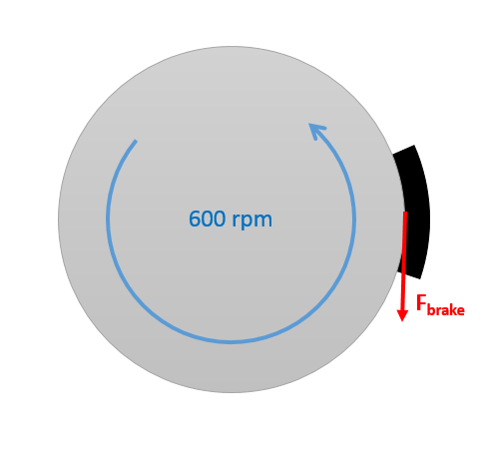

(Solution: $F_{brake}=39.01 lbs$)

Problem 14.2

A ring shaped space station can be approximated as a thin ring 60 meters in diameter with a mass of 500,000 kg. Centrifugal acceleration of the spinning station will be used to simulate gravity.

1. To simulate the 9.81 m/s2 of earth, how fast will the station need to be spinning.
2. If two thrusters each capable of exerting 10 kN of force will be used to get the station up to this speed, how long will we need to run the thrusters?

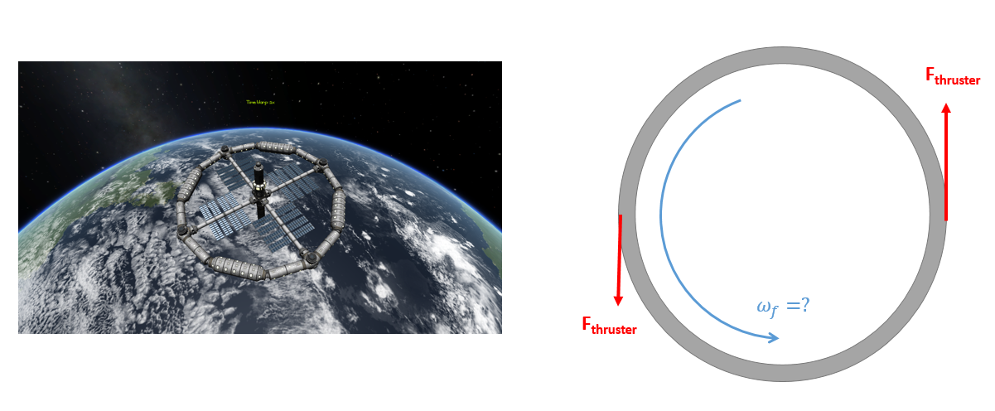

(Solution: $ω_{f}=.571\frac{rad}{s}, t_{thrust}=428.25 s$)